**COOK BOOK: YOUR VIRTUAL KITCHEN ASSISTANT**

1. **Introduction**

In today’s fast-paced world, managing daily cooking routines can be time-consuming and stressful. "Your Virtual Kitchen Assistant" is a smart web application built to simplify kitchen tasks by helping users discover recipes, plan meals, and organize grocery shopping—all in one place.

This project aims to bring convenience to home cooks by acting as a personal cooking assistant. From suggesting dishes based on available ingredients to creating automated shopping lists and storing favorite recipes, it enhances the overall cooking experience. The user-friendly interface and intuitive features make it ideal for beginners and experienced cooks alike.

**• Project Title:** Cook Book: Your Virtual Kitchen Assistant

**• Team ID-**NM2025TMID48796

* **Team Leader:** Liketha [J-likethajalapathi@gmail.com](mailto:J-likethajalapathi@gmail.com)

**2. Project Overview**

**• Purpose:**

SB Works connects clients and freelancers through project postings, bidding, and

real-time communication.

CookBook is a web-based application designed to assist users in managing their kitchen needs virtually. It acts as a digital cooking companion, helping users discover, save, and organize recipes, plan meals, and manage shopping lists efficiently.

* **Key Goals:**
* Provide users with a searchable and categorized recipe collection.
* Allow users to create and manage personal recipe books.
* Enable users to plan meals weekly or monthly.
* Generate automatic shopping lists based on selected recipes.
* Offer cooking tips, nutrition facts, and serving size adjustments.
* Improve kitchen productivity through a simple and intuitive interface.
* **Features:**

**1. Recipe Search**

- Users can search for recipes by name, ingredients, or category.

**2. Add Your Own Recipes**

- Users can upload and manage their own custom recipes with images, steps, and ingredients.

**3. Step-by-Step Cooking Instructions**

- Clear instructions with timers or progress indicators to help users cook easily.

**4. Ingredient-Based Suggestions**

- Suggests recipes based on available ingredients at home.

**5. Favorites/Bookmark Recipes**

- Save favorite recipes for quick access later.

**6. Responsive UI**

- Works smoothly on mobile, tablet, and desktop.

**7. User Accounts**

- Sign up/log in to save preferences and access personalized features.

**8. Meal Planner**

- Users can plan meals for the week and generate a shopping list.

**9. Shopping List Generator**

- Automatically creates a shopping list based on selected recipes.

**10. Voice Assistance (Optional)**

- For hands-free cooking guidance.

* **Project posting and bidding**

Users (clients) can post cooking-related projects like “Create a meal plan for diabetics” or “Design a weekly grocery list.” Other users (freelance cooks, nutritionists, or contributors) can view these posts and place bids or proposals to take up the task.

**- Recipe Discovery:**

Users can browse or search recipes based on ingredients, cuisine, meal type, or dietary preferences.

**- Virtual Pantry:**

Maintain a list of ingredients available at home, which helps suggest recipes without needing to shop.

**- Smart Grocery List:**

Automatically generate a grocery list based on selected recipes or weekly meal plans.

**- Meal Planning:**

Schedule meals for the week and get notifications or reminders.

**- Favorites and Collections:**

Save favorite recipes and organize them into custom collections.

**- User Profiles:**

Each user has a customizable profile showing posted projects, saved recipes, and bidding history.

**- Ratings and Reviews:**

Users can rate and review contributors who assist with posted projects or meal plans.

* **Secure chat system**

The platform includes an end-to-end encrypted chat feature that allows clients and contributors (like chefs, dietitians, etc.) to communicate in real-time. This ensures that project details, recipe modifications, or dietary preferences can be discussed safely and privately.

**- Project Posting and Bidding:**

Clients can post kitchen-related tasks or recipe requests, and users can bid to contribute or assist.

**- Recipe Discovery & Filtering:**

Easily search recipes by ingredients, cooking time, cuisine, or dietary needs.

**- Meal Planner & Grocery List Generator:**

Plan meals and auto-generate shopping lists based on chosen recipes.

**- User Profiles & History:**

Track past interactions, saved recipes, and project participation.

* **Feedback and review system**

After each recipe contribution or virtual assistance task, users can leave feedback and rate the performance. This system builds trust by helping others identify reliable contributors and ensures continuous improvement through constructive reviews.

* **Admin control panel**

The admin dashboard provides full control over the platform, allowing administrators to manage users, monitor activities, approve or reject content (like recipes), handle reports/complaints, and maintain overall system integrity. It ensures the smooth and secure functioning of the virtual kitchen assistant.

**3. Architecture**

• **Frontend:** React.js with Bootstrap and Material UI

- **React.js**: Handles dynamic user interface and component rendering.

- **Bootstrap**: Provides a responsive grid and quick UI elements.

- **Material UI**: Enhances design consistency and adds modern components like dialogs, cards, and forms.

**- Features:**

- Recipe browsing

- Recipe submission form

- Step-by-step instructions

- Shopping list UI

- User login/register pages

• **Backend:** Node.js and Express.js managing server logic and API endpoints

- **Node.js**: JavaScript runtime to run backend code.

- **Express.js**: Framework for routing and handling RESTful API calls.

- **Responsibilities:**

- User authentication

- CRUD operations for recipes

- Storing/retrieving shopping lists

- Chat/message routes (if applicable)

• **Database:** MongoDB stores user data, project information, applications, and chat messages

- Stores:

- User profiles

- Saved/bookmarked recipes

- Uploaded recipes

- Ingredients list

- Meal plans/shopping lists

- (Optional) Chat messages between users

**4. Setup Instructions**

**• Prerequisites:**

**– Node.js**

For running JavaScript on the server side and managing packages with npm.

**– MongoDB**

NoSQL database used to store user data, recipes, and other application data.

**– Git**

Version control system used to clone the project repository and manage code changes.

**– React.js**

JavaScript library for building the frontend user interface.

– **Express.js – Mongoose – Visual Studio Code**

**Express.js**-Web framework for Node.js to handle routing and API endpoints.

**Mongoose**-ODM (Object Data Modeling) library for MongoDB and Node.js, used to define schemas and interact with the database.

**Visual Studio Code**- Recommended code editor for writing and managing project files.

**• Installation Steps:**

# Clone the repository git clone

# Install client dependencies cd

client npm install

# Install server dependencies cd

../server npm install

**5. Folder Structure**

SB-Works/

|-- client/ # React frontend

|__components/

L__ pages/

|__ server/ # Node.js backend

|__routes/

|__ models/

|__ controllers/

**6. Running the Application**

**• Frontend:**

cd client

npm start

**•Backend:**

cd server npm

start

• **Access:** Visit http://localhost:3000

**7. API Documentation**

**• User:**

– /api/user/register

– /api/user/login

**• Projects:**

– /api/projects/create

– /api/projects/:id • Applications: /api/apply

**• Chats:**

– /api/chat/send

– /api/chat/:userId

**8. Authentication**

• JWT-based authentication for secure login

• Middleware protects private routes

**9. User Interface**

• Landing Page

• Freelancer Dashboard

• Admin Panel

• Project Details Page

**10. Testing**

• Manual testing during milestones

• Tools: Postman, Chrome Dev Tools

**11. Screenshots or Demo**

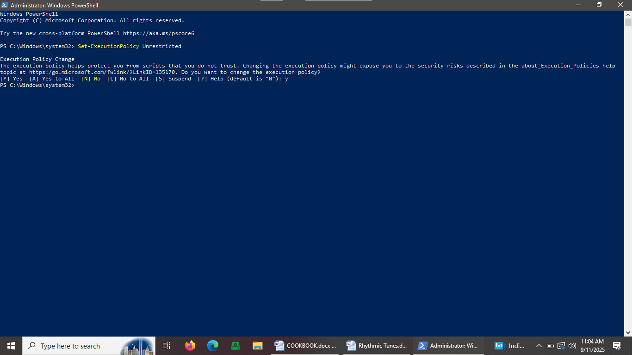

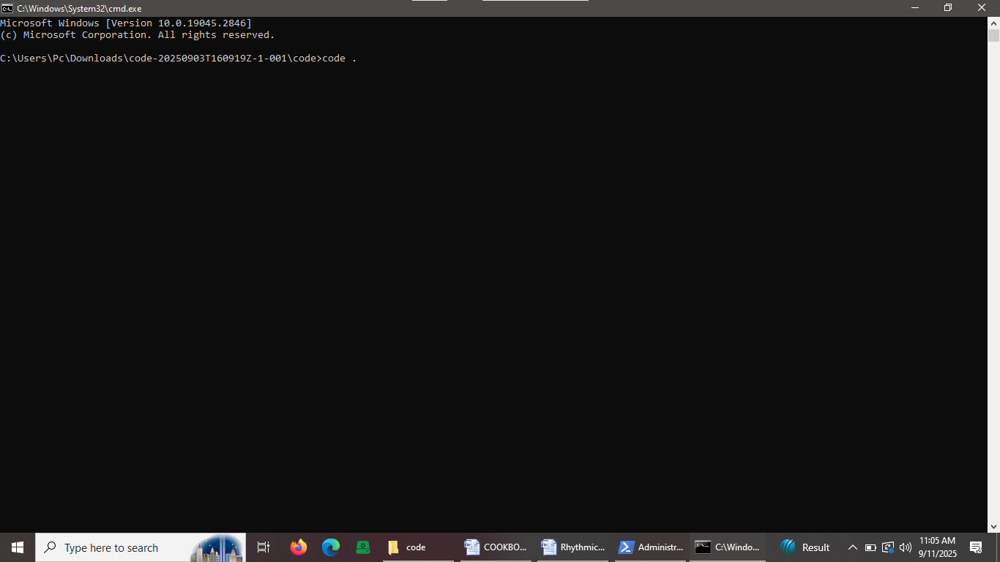

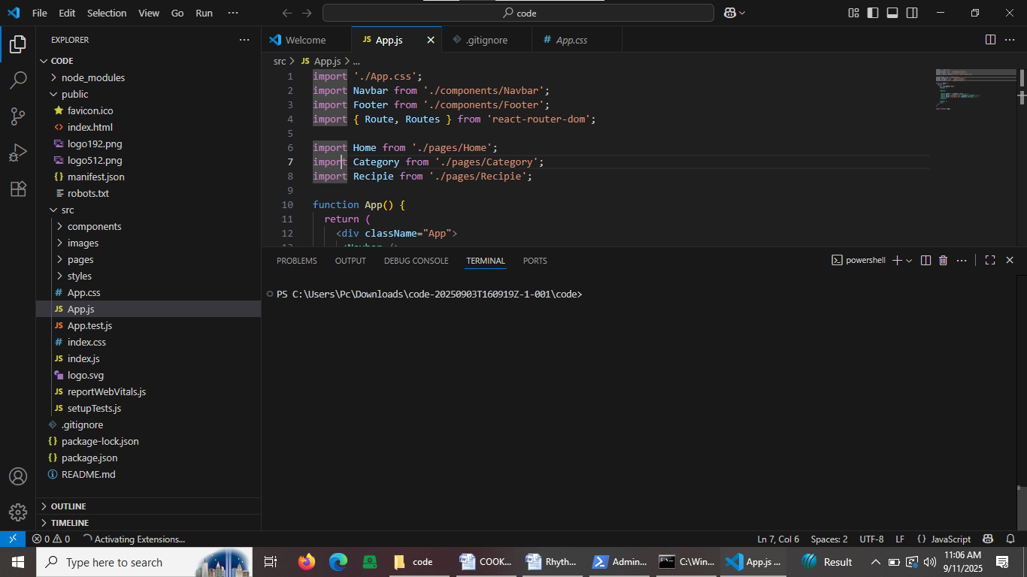

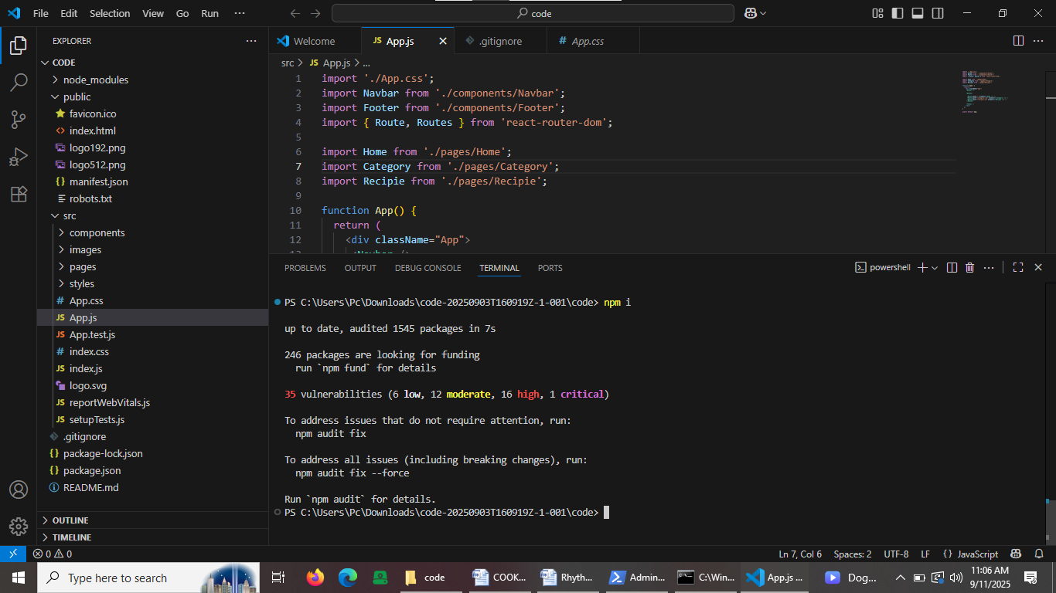

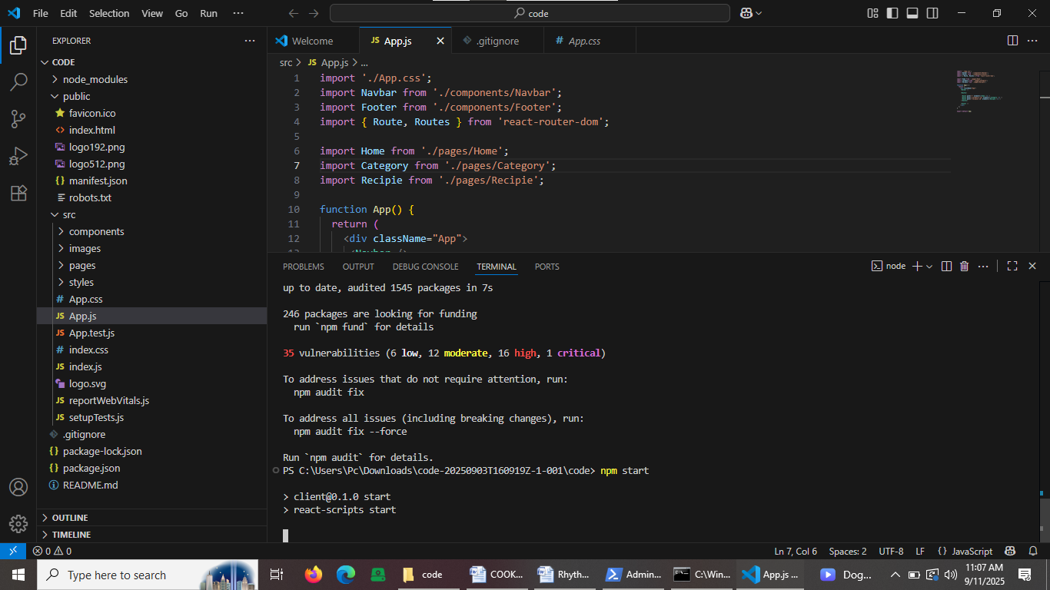

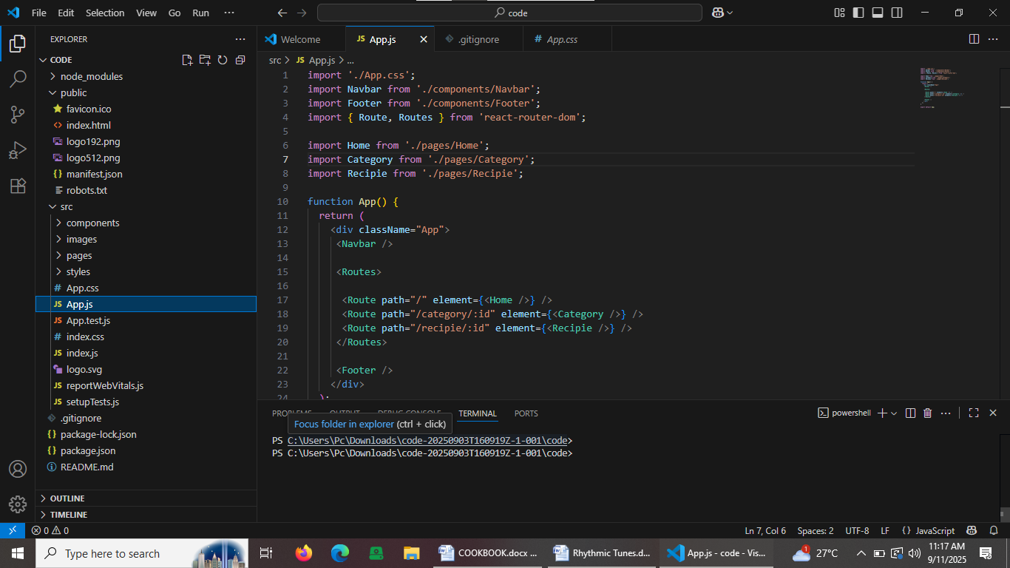

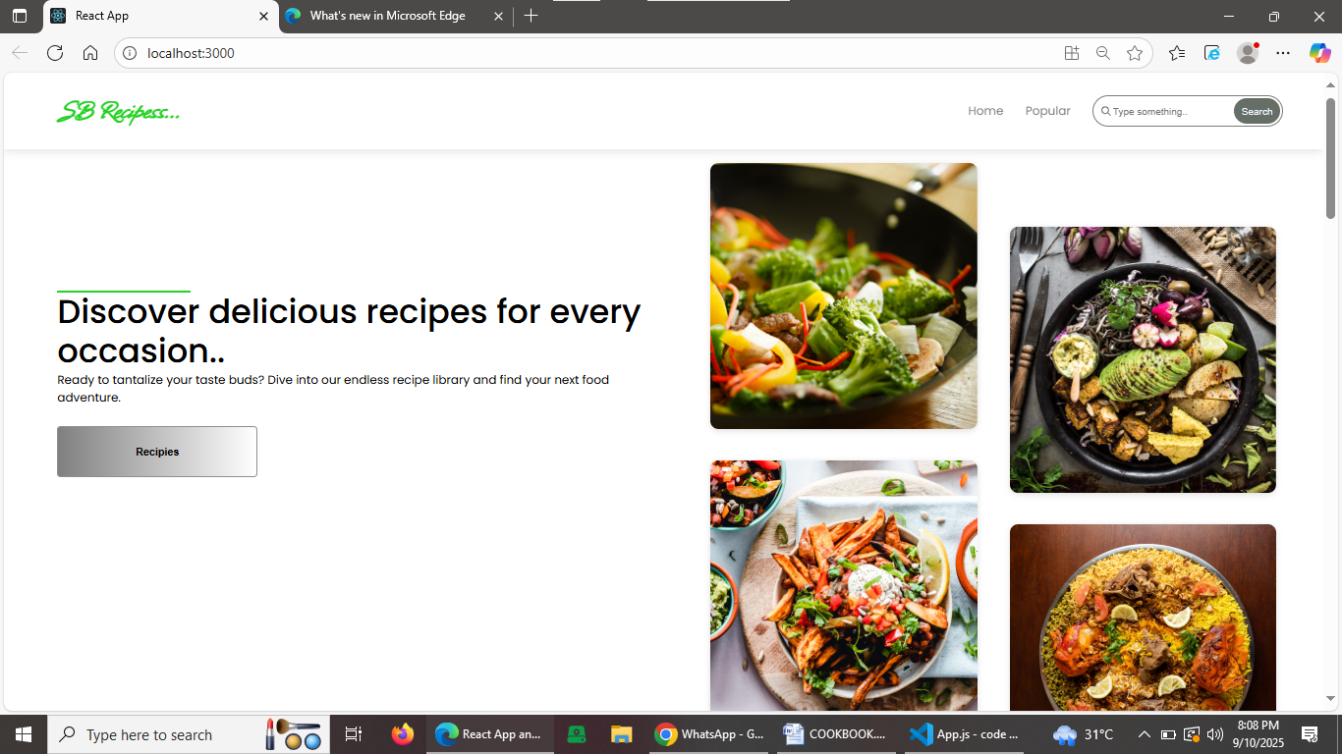

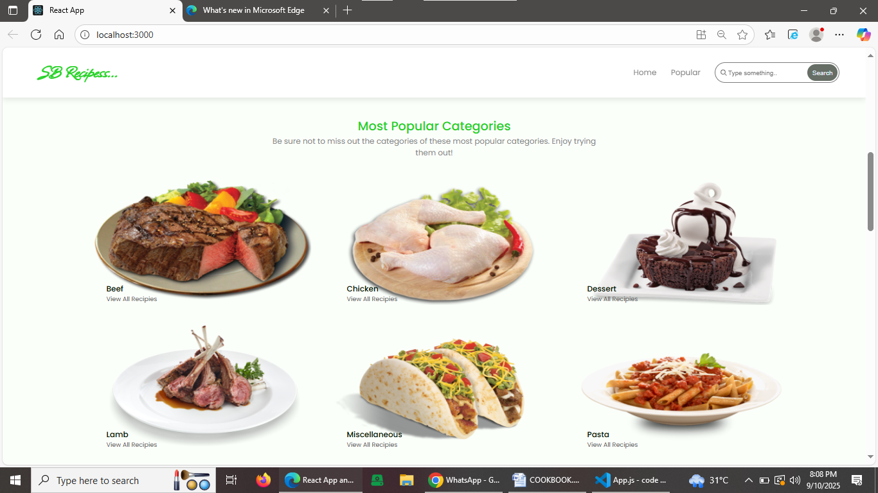

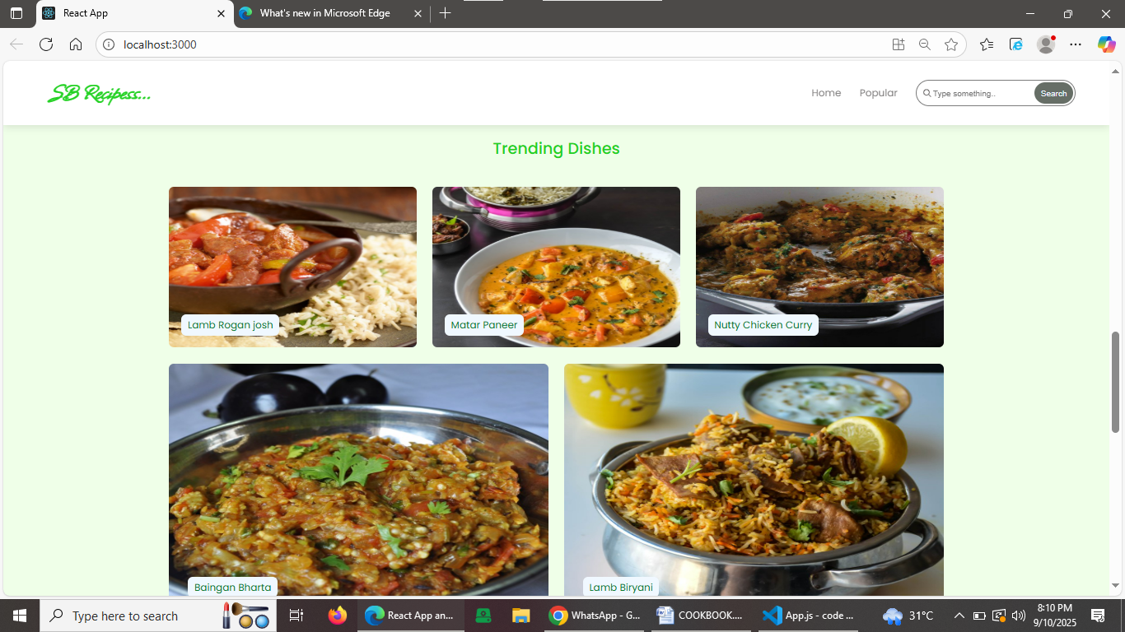

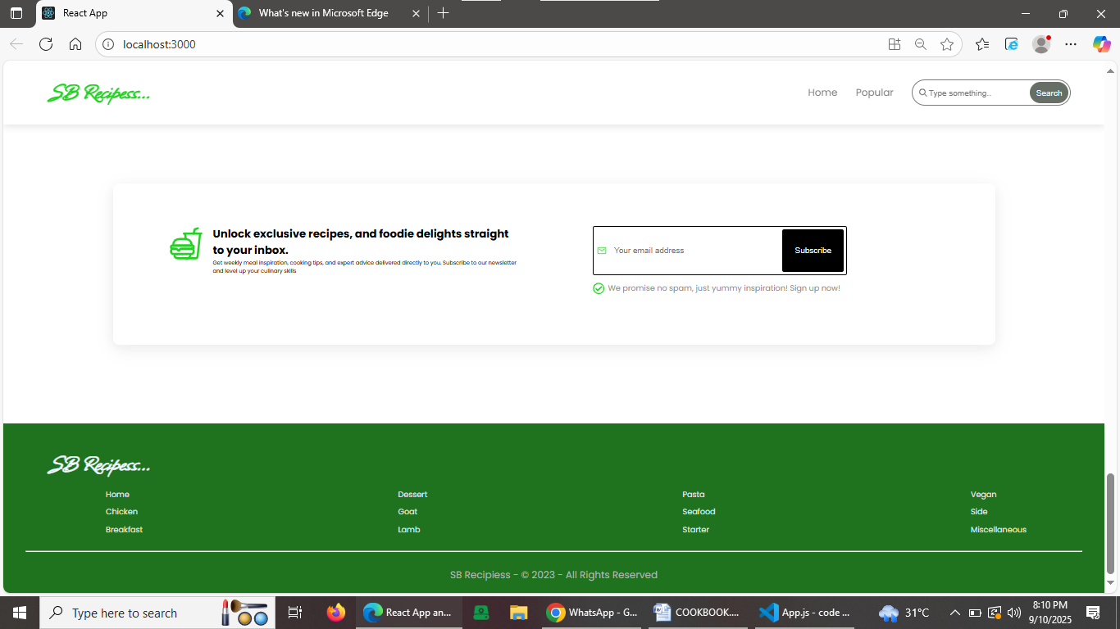

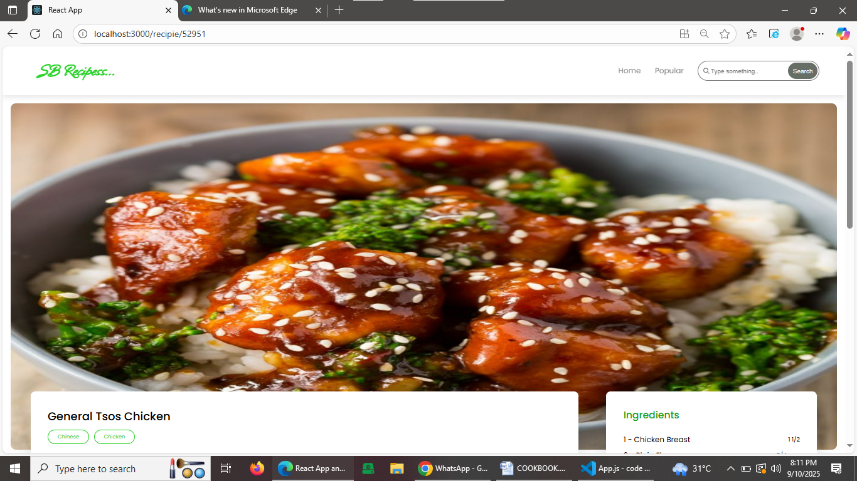

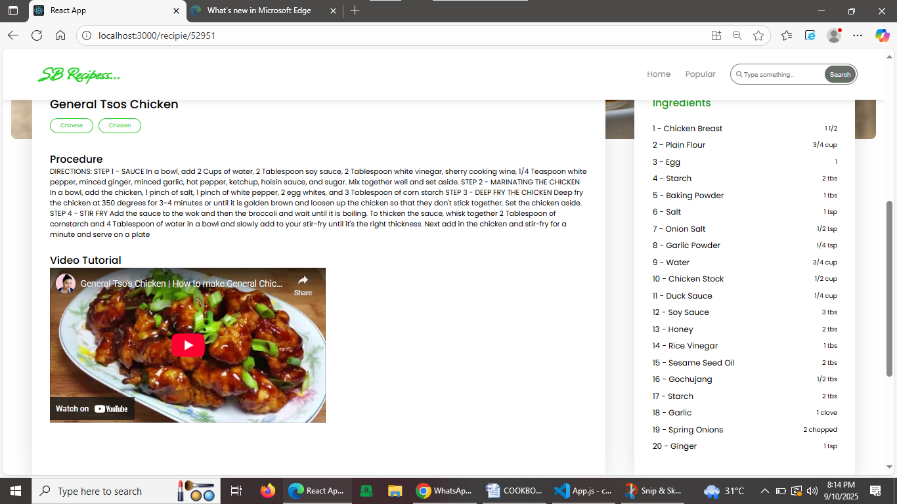

**12. Known Issues**

- **Intermittent delay** in loading recipes during peak usage times.

- **Search filters** sometimes return incomplete results for complex queries.

- **Chat notifications**  may not always appear in real-time for all users.

- **Mobile responsiveness**  needs improvement on some smaller screen sizes.

- Occasional **session timeout** issues requiring users to log in again.

- Limited **error handling** for certain edge cases in form submissions.

- No **offline support** ; the app requires constant internet connection.

**13. Future Enhancements**

- **Advanced recipe recommendations** using AI and user preferences.

- **Voice command integration** for hands-free cooking assistance.

- **Offline mode** to access saved recipes without internet.

- **Personalized meal planning** and grocery list generation.

- **Social sharing features** to share recipes and cooking tips.

- **Video tutorials** and step-by-step cooking guides.

- **Improved mobile responsiveness** and dedicated mobile app.

- **Enhanced chat system** with file sharing and emojis.

- **Multi-language support** to reach a wider audience.

- **User achievements and gamification** to boost engagement.